**SIT223 – Professional Practice in Information Technology**

**Task 7.1G - Sprint planning in Trello (File 2)**

1. **Activities related to both sprints.**
   * 1. Sprint 1 – Sprint one focused on deciding upon a project for the assessment, meeting team members and creating the basic building blocks for the website.
        1. After deciding on the project that we were going to complete the following tasks were completed:
           1. **Cam** started the contact form and created its required.

CSS, PHP and HTML Files.

* + - * 1. **Syed** created the creating the Inquiry/submissions page
        2. **Caitlyn** created the outline for what she intends to include in her login page.
        3. **Kyria** Created an outline for what she intends to include in her Vehicle Form page.
    1. Sprint 2 – Sprint two is likely to involve the follow the structure depicted in the image bellow, however this is subject to change.
       1. The likely tasks are:
          1. **Cam** Create an email verification system that contributes to his role in cyber security.
          2. **Syed** creating the tables and the logical structure for the database input.
          3. **Caitlyn** will develop a notification system that will allow users to receive updates regarding the safety of their vehicle.
          4. **Kyria** Created an outline for what she intends to include in her Vehicle Form page.
    2. During the first sprit we focused on the completion of the following OnTrack tasks:
       1. 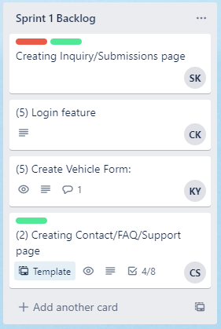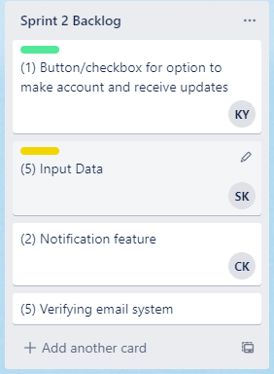7.1G and 8.1G:

1. Features to be investigated/implemented and tasks.

Potential features to be investigated and/or implemented may include:

* + A how to use page, short 1-2-minute video explaining how to use the age.
  + FAQ and Contact support page, to allow the consumer to contact us for any issues
  + Inquiries page for a consumer to use if their vehicle has faults but isn't listed on the website then CheckYourCar can investigate
  + Vehicle Form used to search the databases
  + An extension to the vehicle form if someone isn't already logged in, to create an account
  + Checkbox to offer to receive email updates otherwise logging into the web portal will inform the user
  + A future ability to link into manufacture databases of vehicle faults for automatic alerting to consumers of given car models.
  + The creation of emailing groups for each vehicle, based on any recall updates.
  + Creating a secure login portal
  + Notification area and settings when logged in on the web portal

1. Members of the team assigned to tasks and features
   * For team roles and current tasks for sprint one and sprint two refer to question 1.
   * 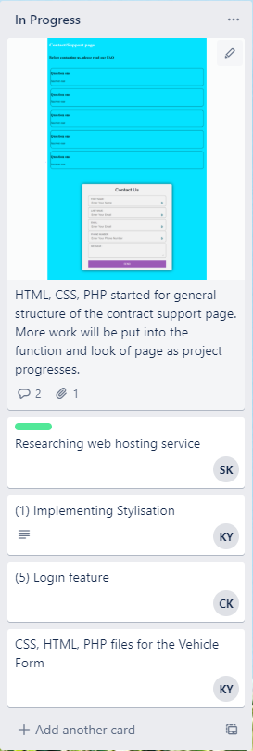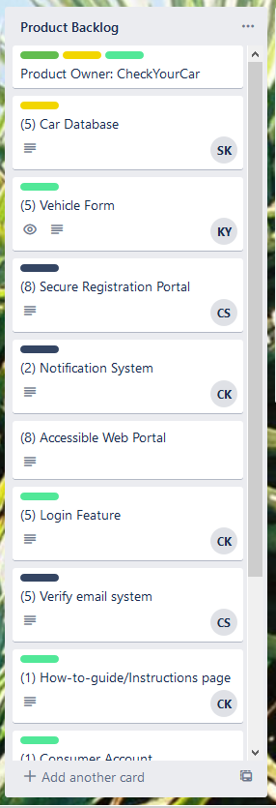The In Progress screenshot to the right headlights the activities that we are currently working on for our sprint one.
   * Please refer to the completed screenshot to see which tasks are 100% done for sprint one.

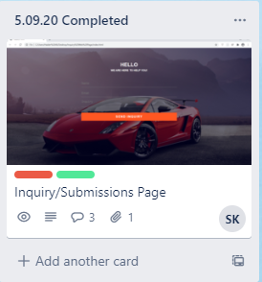

1. List of resources (links to resources, in dedicated Trello list).

* MS Teams – used to communicate meeting logistics in chat feature, while the meeting feature .is used for sprint planning and discussing feedback.
* GitHub – used to share code files.
  + Link: <https://github.com/cdsmith-deakin/Group---SIT223>.
* Visual Studio Code – used to collaborate our code through the Live Share function.
* OneDrive - used to share documents needed to be submitted.

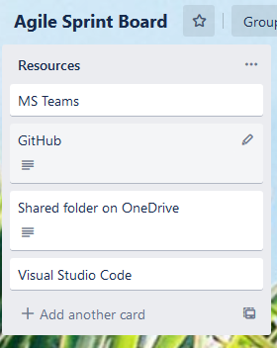Link: <https://deakin365-my.sharepoint.com/personal/cdsmith_deakin_edu_au/_layouts/15/onedrive.aspx>.

1. Ownership roles – C Criteria (this needs to be in its own dedicated Trello list).

Each member is allocated to their ownership roles as follows:

* + Cam – Scrum Master and Security Features: Cameron
  + Caitlyn – Scrum Team: UX
  + Kyria – Scrum Team: UI and Front-end and Back-end Communication
  + Syed – Scrum Team: Database

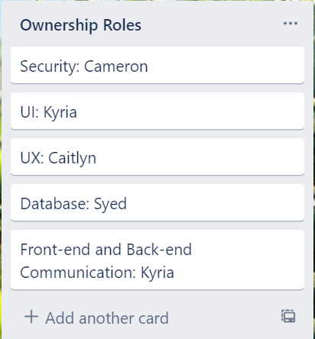These are in its own Trello list:

f. User stories - D Criteria

|  |  |
| --- | --- |
| Product Backlog items and User stories | Features |
|  | * Regularly updating database when new vehicle models are launched. * Displays vehicle model. * Display vehicle registration number. * Displays vehicle year of make. |
|  | * Label optional fields * Real-time validation to check if email is already registered * Let users stay signed in after they register * Create login page with HTML and CSS |
|  | * Implement ‘https’ * Prepare SQL Queries to prevent SQL injection * Basic validation for username and password |
|  | * Notification through email * Allow users to enable notifications on mobile * Notification section when logged in on the website |
|  | * Let users view their user account when they log in * Navigation bar with links to main pages, login and signup pages |
|  | * 2 separate options to either ‘Sign up’ or ‘sign in’ * Let users see their password * Let users have option to remember user * Let users sign in with their email address or phone number |
|  | * Requires inputting account details during registrations * Prompts the system to send a message to the provided emails * User receives link to confirm email |
|  | * CSS - Use consistent, easy-to-read fonts * Design that is consistent with the company’s colours * HTML - Hierarchical structure of information |
|  | * Requires an e-mail and password. * Also requires a unique username. * Information regarding vehicle such as vehicle registration number will be stored. |
|  | * Require users name and e-mail. * Form is filled and I receive the inquiry through the php coding. * Web hosting services will be used to achieve this feature. |
|  | * Answers to common questions rising among customers. * Additional contacts are provided such as e-mails and phone number to provide further assistance. |

1. Story points - HD Criteria

|  |  |  |
| --- | --- | --- |
| Features | Story point | Justification |
| Car Database | 5 | The car database will require a significant amount of time for the development of database tables for each component of the site, including tables for:   * User * Vehicles * Other variables   Thus, the team has assigned the difficulty of 5. |
| Vehicle Form | 5 | The vehicle form must include sub sections that allow input for the following fields:   * A section for car manufacture. * A section for car model * A section for year of manufacture * A section for transmission type.   This information will then be inputted into the aforementioned SQL tables. Tables will exist for each vehicle and the user’s details will be inputted into that table, allowing for the creation of mailing lists.  This justifies the assigned difficulty of 5. |
| Secure Registration Portal | 8 | The creation of the secure registration portal is likely to be a difficult task to create and implement. Security is always a difficult task to implement due the requirements of threat identification and prevention.  This justifies the assigned difficulty of 8. |
| Notification System | 2 | A notification system is likely to be an easy tool to implement, as a simple file can be created with a function that can be implemented into each SQL table to notify customers of when a fault occurs in their vehicle.  This justifies the assigned difficulty of 2. |
| Accessible Web Portal | 8 | This is the entire system of forms and pages – Essentially the final product. The implementation of all aspects of the project working in tandem to create a working site.  This justifies the assigned difficulty of 5. |
| Login Feature | 5 | A login feature will need to connect to take user input and connect this information to the SQL tables for users in the back end of the system. The creation of the web page is likely to be relatively easy but ensuring its integration with the site’s backend is likely to be difficult.  This justifies the assigned difficulty of 5. |
| Email verification system | 5 | An email verification system is likely to require a significant amount of PHP in order to ensure that the system is secure. System security will likely be difficult to create, |
| How-to-guide/Instructions page | 1 | This page does not require any user input and is simply provides text to the user.  Thus, this task is rated at a level 1 in difficulty. |
| Consumer Registration Account | 3 | The customer registration portal will link with other functions such as the email verification form. It will take user input and then record this information in the SQL tables.  This justifies the assigned difficulty of 3. |
| Inquiry/Submissions page | 2 | The inquiry/submission page will require a small php function to implement a send to email function. This will forward the site email customer queries.  This justifies the assigned difficulty of 2. |
| FAQ/ contact page | 2 | This page is likely to be similar to the Inquiry/submissions page, in that It requires a php file to forward a customer email onto the sites email address  This justifies the assigned difficulty of 2. |